

**Lab report-04**

**Submitted to**

**Hasin Rehana**

**Lecturer in Computer Science and Engineering**

**Daffodil International University**

**Submitted By**

**Md. Amirul Islam**

**Id No: 181-15-1748**

**Section: PC-A**

**Daffodil International University**

**Date: 26-07-2021**

**Experiment No: 04**

**Experiment Name: motion object with circle.**

**Lab Code:**

**#include <windows.h>**

**#include <GL/gl.h>**

**#include <GL/glut.h>**

**#include<math.h>**

**float j=0.0;**

**void car()**

**{**

**//cars**

**if(j<1.0)**

**{**

**j=j+0.001;**

**}**

**else**

**{**

**j=0.0;**

**}**

**glColor3f(1.0, 1.0, 1.0);**

**glBegin(GL_QUADS);**

**glVertex2d(0.0+j,0.12);**

**glVertex2d(0.14+j,0.12);**

**glVertex2d(0.14+j, 0.15);**

**glVertex2d(0.0+j,0.15);**

**glEnd();**

**glColor3f(0.0, 0.0, 1.0);**

**glBegin(GL_QUADS);**

**glVertex2d(0.05+j,0.15);**

**glVertex2d(0.11+j,0.15);**

**glVertex2d(0.09+j, 0.18);**

**glVertex2d(0.05+j,0.18 );**

**glEnd();**

**glColor3f(0.0f,0.8f,0.0f);**

**glBegin(GL_TRIANGLES);**

**glVertex2d(0.02+j,0.15);**

**glVertex2d(0.05+j,0.15);**

**glVertex2d(0.05+j, 0.18);**

**glEnd();**

**glColor3f(1.0f,0.0f,0.5f);**

**glBegin(GL_QUADS);**

**glVertex2d(0.06+j,0.12);**

**glVertex2d(0.09+j,0.12);**

**glVertex2d(0.09+j, 0.15);**

**glVertex2d(0.06+j, 0.15);**

**glEnd();**

**glColor3f(0.0f,1.0f,0.0f);**

**glBegin(GL_POLYGON);**

**int theta;**

**for(int i=0; i<2880; i++)**

**{**

**theta=i*(3.1416/180);**

**glVertex2f(0.04+j+0.02*sin(theta),0.12+0.02*cos(theta));**

**}**

**glEnd();**

**glColor3f(0.0f,1.0f,0.0f);**

**glBegin(GL_POLYGON);**

**for(int i=0; i<2880; i++)**

**{**

**theta=i*(3.1416/180);**

**glVertex2f(0.11+j+0.02*sin(theta),0.12+0.02*cos(theta));**

**}**

**glEnd();**

**glutPostRedisplay();**

**}**

**void display(void)**

**{**

**glClear (GL_COLOR_BUFFER_BIT);**

**glBegin(GL_QUADS);**

**glColor3f(0.2,0.2,0.2);**

**glVertex3f(0.0, 0.0, 0.0); //background**

**glVertex3f(1.0, 0.0, 0.0);**

**glVertex3f(1.0, 1.0, 0.0);**

**glVertex3f(0.0, 1.0, 0.0);**

**glColor3f (0.3, 0.2,0);**

**glVertex3f(0.1, 0.3, 0.0); //field**

**glVertex3f(0.5, 0.3, 0.0);**

**glVertex3f(0.5, 0.6, 0.0);**

**glVertex3f(0.1, 0.6, 0.0);**

**glColor3f (0.1f, 0.2f, 0.0f); //debox**

**glVertex3f(0.1, 0.35, 0.0);**

**glVertex3f(0.18, 0.35, 0.0);**

**glVertex3f(0.18, 0.55, 0.0);**

**glVertex3f(0.1, 0.55, 0.0);**

**glColor3f (0.1f, 0.3f, 0.0f); //penalty box**

**glVertex3f(0.1, 0.4, 0.0);**

**glVertex3f(0.14, 0.4, 0.0);**

**glVertex3f(0.14, 0.5, 0.0);**

**glVertex3f(0.1, 0.5, 0.0);**

**glColor3f (0.1f, 0.2f, 0.0f); //debox 2**

**glVertex3f(0.5, 0.35, 0.0);**

**glVertex3f(0.42, 0.35, 0.0);**

**glVertex3f(0.42, 0.55, 0.0);**

**glVertex3f(0.5, 0.55, 0.0);**

**glColor3f (0.1f, 0.3f, 0.0f); //penalty box 2**

**glVertex3f(0.5, 0.4, 0.0);**

**glVertex3f(0.46, 0.4, 0.0);**

**glVertex3f(0.46, 0.5, 0.0);**

**glVertex3f(0.5, 0.5, 0.0);**

**glColor3f (0.0f, 0.1f, 0.0f); //house**

**glVertex3f(0.7, 0.3, 0.0);**

**glVertex3f(0.85, 0.3, 0.0);**

**glVertex3f(0.85, 0.4, 0.0);**

**glVertex3f(0.7, 0.4, 0.0);**

**glColor3f (0.0f, 0.1f, 0.1f); //path**

**glVertex3f(0.73, 0.2, 0.0);**

**glVertex3f(0.78, 0.2, 0.0);**

**glVertex3f(0.8, 0.3, 0.0);**

**glVertex3f(0.75, 0.3, 0.0);**

**glColor3f (0.5f, 0.5f, 0.5f); //siri**

**glVertex3f(0.69, 0.29, 0.0);**

**glVertex3f(0.86, 0.29, 0.0);**

**glVertex3f(0.86, 0.3, 0.0);**

**glVertex3f(0.69, 0.3, 0.0);**

**glColor3f (0.5f, 0.5f, 0.5f); //door**

**glVertex3f(0.75, 0.3, 0.0);**

**glVertex3f(0.8, 0.3, 0.0);**

**glVertex3f(0.8, 0.37, 0.0);**

**glVertex3f(0.75, 0.37, 0.0);**

**glColor3f (0.5f, 0.0f, 0.0f); //door kopat**

**glVertex3f(0.75, 0.3, 0.0);**

**glVertex3f(0.78, 0.32, 0.0);**

**glVertex3f(0.78, 0.35, 0.0);**

**glVertex3f(0.75, 0.37, 0.0);**

**glColor3f (0.5f, 0.5f, 0.5f); //windows1**

**glVertex3f(0.71, 0.33, 0.0);**

**glVertex3f(0.74, 0.33, 0.0);**

**glVertex3f(0.74, 0.37, 0.0);**

**glVertex3f(0.71, 0.37, 0.0);**

**glColor3f (0.5f, 0.5f, 0.5f); //windows2**

**glVertex3f(0.81, 0.33, 0.0);**

**glVertex3f(0.84, 0.33, 0.0);**

**glVertex3f(0.84, 0.37, 0.0);**

**glVertex3f(0.81, 0.37, 0.0);**

**glColor3f (0.0f, 0.1f, 0.1f); //road 1**

**glVertex3f(0.0, 0.0, 0.0);**

**glVertex3f(1.0, 0.0, 0.0);**

**glVertex3f(1.0, 0.2, 0.0);**

**glVertex3f(0.0, 0.2, 0.0);**

**glColor3f (0.0f, 0.1f, 0.1f); //road 2**

**glVertex3f(0.54, 0.0, 0.0);**

**glVertex3f(0.64, 0.0, 0.0);**

**glVertex3f(0.64,1.0,0.0);**

**glVertex3f(0.54, 1.0, 0.0);**

**/* glColor3f (0.0f, 0.0f, 0.4f); //river**

**glVertex3f(0.0,0.7, 0.0);**

**glVertex3f(1.0, 0.7, 0.0);**

**glVertex3f(1.0,1.0,0.0);**

**glVertex3f(0.0, 1.0, 0.0);*/**

**glColor3f (1.0f, 1.0f, 1.0f); //dag 1**

**glVertex3f(0.02, 0.09, 0.0);**

**glVertex3f(0.07, 0.09, 0.0);**

**glVertex3f(0.07,0.11, 0.0);**

**glVertex3f(0.02,0.11,0.0);**

**glColor3f (1.0f, 1.0f, 1.0f); //dag 2**

**glVertex3f(0.3, 0.09, 0.0);**

**glVertex3f(0.37, 0.09, 0.0);**

**glVertex3f(0.37,0.11, 0.0);**

**glVertex3f(0.3,0.11,0.0);**

**glColor3f (1.0f, 1.0f, 1.0f); //dag 3**

**glVertex3f(0.6, 0.09, 0.0);**

**glVertex3f(0.68, 0.09, 0.0);**

**glVertex3f(0.68,0.11, 0.0);**

**glVertex3f(0.6,0.11,0.0);**

**glColor3f (1.0f, 1.0f, 1.0f); //dag 4**

**glVertex3f(0.82, 0.09, 0.0);**

**glVertex3f(0.92, 0.09, 0.0);**

**glVertex3f(0.92,0.11, 0.0);**

**glVertex3f(0.82,0.11,0.0);**

**glColor3f (0.3, 0.2,0.0); //tree1**

**glVertex3f(0.04, 0.25, 0.0);**

**glVertex3f(0.06, 0.25, 0.0);**

**glVertex3f(0.06,0.35, 0.0);**

**glVertex3f(0.04,0.35,0.0);**

**glColor3f (0.3, 0.2, 0.0f); //tree2**

**glVertex3f(0.93, 0.3, 0.0);**

**glVertex3f(0.95, 0.3, 0.0);**

**glVertex3f(0.95,0.4, 0.0);**

**glVertex3f(0.93,0.4,0.0);**

**glEnd();**

**glBegin(GL_TRIANGLES);**

**glColor3f(0.5,0.5,0.5); //roof**

**glVertex3f(0.65,0.395,0.0);**

**glVertex3f(0.895,0.395,0.0);**

**glVertex3f(0.775,0.47,0.0);**

**glColor3f(0.5,0.3,0.1); //shade**

**glVertex3f(0.67,0.4,0.0);**

**glVertex3f(0.88,0.4,0.0);**

**glVertex3f(0.775,0.46,0.0);**

**glColor3f(0.1f, 0.2f, 0.0f); //t1 triangle**

**glVertex3f(0.02,0.35,0.0);**

**glVertex3f(0.08,0.35,0.0);**

**glVertex3f(0.05,0.4,0.0);**

**glColor3f(0.1f, 0.2f, 0.0f);**

**glVertex3f(0.02,0.37,0.0);**

**glVertex3f(0.08,0.37,0.0);**

**glVertex3f(0.05,0.42,0.0);**

**glColor3f(0.1f, 0.2f, 0.0f);**

**glVertex3f(0.02,0.39,0.0);**

**glVertex3f(0.08,0.39,0.0);**

**glVertex3f(0.05,0.44,0.0);**

**glColor3f(0.1f, 0.2f, 0.0f); //t2 triangle**

**glVertex3f(0.91,0.4,0.0);**

**glVertex3f(0.97,0.4,0.0);**

**glVertex3f(0.94,0.46,0.0);**

**glColor3f(0.1f, 0.2f, 0.0f);**

**glVertex3f(0.91,0.42,0.0);**

**glVertex3f(0.97,0.42,0.0);**

**glVertex3f(0.94,0.48,0.0);**

**glColor3f(0.1f, 0.2f, 0.0f);**

**glVertex3f(0.91,0.44,0.0);**

**glVertex3f(0.97,0.44,0.0);**

**glVertex3f(0.94,0.5,0.0);**

**glEnd();**

**glBegin(GL_LINES); //bar post**

**glColor3f(1,1,1);**

**glVertex3f(0.1,0.43,0.0);**

**glVertex3f(0.09,0.43,0.0);**

**glColor3f(1,1,1);**

**glVertex3f(0.09,0.43,0.0);**

**glVertex3f(0.09,0.47,0.0);**

**glColor3f(1,1,1);**

**glVertex3f(0.1,0.47,0.0);**

**glVertex3f(0.09,0.47,0.0);**

**glColor3f(1,1,1); //bar post 2**

**glVertex3f(0.5,0.43,0.0);**

**glVertex3f(0.51,0.43,0.0);**

**glColor3f(1,1,1);**

**glVertex3f(0.51,0.43,0.0);**

**glVertex3f(0.51,0.47,0.0);**

**glColor3f(1,1,1);**

**glVertex3f(0.51,0.47,0.0);**

**glVertex3f(0.5,0.47,0.0);**

**glColor3f(0.2,0.5,0.0); //middle line**

**glVertex3f(0.3,0.3,0.0);**

**glVertex3f(0.3,0.6,0.0);**

**glColor3f(1,1,1); //bar 1**

**glVertex3f(0.59,0.25,0.0);**

**glVertex3f(0.59,0.3,0.0);**

**glColor3f(1,1,1); //bar 2**

**glVertex3f(0.59,0.4,0.0);**

**glVertex3f(0.59,0.47,0.0);**

**glColor3f(1,1,1); //bar 3**

**glVertex3f(0.59,0.55,0.0);**

**glVertex3f(0.59,0.6,0.0);**

**glColor3f(1,1,1); //bar 4**

**glVertex3f(0.59,0.75,0.0);**

**glVertex3f(0.59,0.8,0.0);**

**glColor3f(1,1,1); //bar 5**

**glVertex3f(0.59,0.9,0.0);**

**glVertex3f(0.59,0.95,0.0);**

**glColor3f(0,0.1,0); //window 1 dag**

**glVertex3f(0.71,0.35,0.0);**

**glVertex3f(0.74,0.35,0.0);**

**glColor3f(0,0.1,0); //window 2 dag**

**glVertex3f(0.81,0.35,0.0);**

**glVertex3f(0.84,0.35,0.0);**

**glColor3f(0,0.1,0); //tree 1 dag**

**glVertex3f(0.01,0.25,0.0);**

**glVertex3f(0.09,0.25,0.0);**

**glColor3f(0,0.1,0); //tree 1 dag2**

**glVertex3f(0.03,0.24,0.0);**

**glVertex3f(0.07,0.24,0.0);**

**glColor3f(0,0.1,0); //tree 2 dag2**

**glVertex3f(0.91,0.29,0.0);**

**glVertex3f(0.98,0.29,0.0);**

**glColor3f(0,0.1,0); //tree 2 dag2**

**glVertex3f(0.93,0.28,0.0);**

**glVertex3f(0.96,0.28,0.0);**

**glEnd();**

**car();**

**glFlush ();**

**}**

**void init (void)**

**{**

**glClearColor (0.0, 0.0, 0.0, 0.0); //select clearing (background) color**

**glMatrixMode(GL_PROJECTION);**

**glLoadIdentity();**

**glOrtho(0.0, 1.0, 0.0, 1.0, -10.0, 10.0);**

**}**

**int main(int argc, char** argv)**

**{**

**glutInit(&argc, argv);**

**glutInitDisplayMode (GLUT_SINGLE | GLUT_RGB);**

**glutInitWindowSize (780, 600);**

**glutInitWindowPosition (100, 100);**

**glutCreateWindow ("Amir");**

**init ();**

**glutDisplayFunc(display);**

**glutMainLoop();**

**return 0;**

**}**

**output Screenshot:**

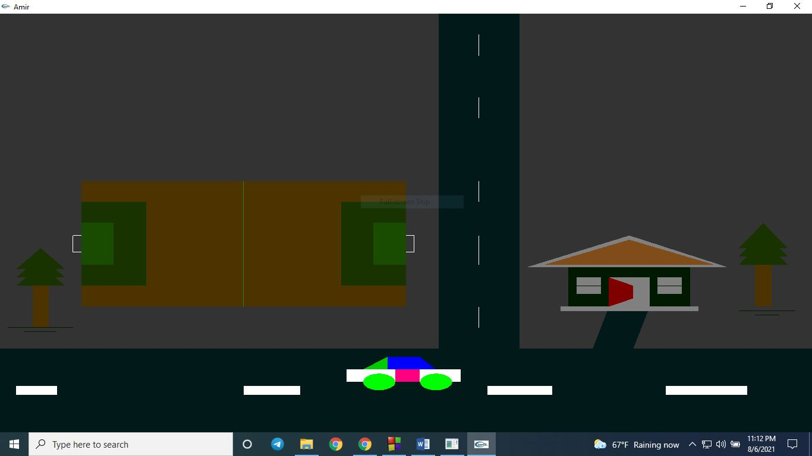

**Discussion:**

In this project I designed a road and a car over the road. The road designed by quads and lines. And the car designed by quads, triangles and circles .The car is moving on the road. I used if else condition for moving the car. I also used a for loop to draw the circles which are the wheels of the car. I also designed a football field using by quads and lines. I also design a house using by quads, triangles and lines. I also design two trees using by quads triangles and lines. All of this design I will draw the graph paper before designing.

**Thank You**